**JULY 3, 2016**

**FOURTEENTH SUNDAY IN ORDINARY TIME “C”**

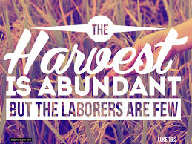

**Chaplain:**

Father Matthew Hysell, M.A., M.Th.

DeafCatholicEdmonton@CAEDM.ca

780-700-0234 text message only

In case of emergency, text to Father Matthew for assistance.

**Pastoral Worker**

Sister Elizabeth Kass, S.P.

780) 701-1817 *TTY*

780) 436-7255 *fax*

780) 446-7317 *text-message*

ekass@sistersofprovidence.ca *email*

**Chairperson**

Mr. John Shores

780-434-8640 *TTY*

John.Shores@ualberta.ca *email*

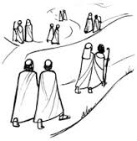

**Jesus sent out his disciples two by two to proclaim the good news to people in the towns he planned to visit**

**ICDA Canadian Section**

**Chapter # 108**

**Website:**

[**www.DeafCatholicEdmonton.org**](http://www.DeafCatholicEdmonton.org)

**Charitable Donation Number**

**11918-6757-RR0001**

**Today’s Readings**

**First Reading:** Isaiah 66:10-14

**Psalm # 66**

**Second Reading:** Galatians 6:14-18

**Gospel**: Luke 10:1-12, 17-20

**Next Sunday – July 10th – 15th Sunday in Ordinary Time “C”**

**First Reading: Deuteronomy 30:10-14**

**Psalm # 69**

**Second Reading: Colossians 1:15-20**

**Gospel: Luke 10:25-37**

**Let us pray for all those whom God calls to his service that they may faithfully answer his call.**

**JULY BIRTHDAYS**

**- Let us pray for REAL BOUCHARD who will be 90 years old tomorrow, July 4th.**

**- Happy Birthday to Marie Douziech whose birthday is also on July 4th.**

**- Happy Birthday to Emma Marcotte on July 15th**

**and Happy Birthday to Bill Orobko on July 26th.**

**Lord, make me an instrument of your peace. Where there is hatred, let me sow love.**

***Prayer of St. Francis***

* *From Live Like Francis*

**Office and Mailing Address**

3005 - 119th Street • Edmonton, Alberta T6J 5R5 • (780) 436-7250