**MAY 22, 2016**

**HOLY TRINITY “C”**

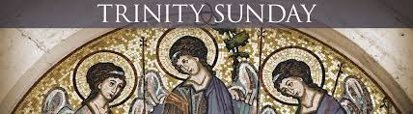

**Chaplain:**

Father Matthew Hysell, M.A., M.Th.

DeafCatholicEdmonton@CAEDM.ca

780-700-0234 text message only

In case of emergency, text to Father Matthew for assistance.

**Pastoral Worker**

Sister Elizabeth Kass, S.P.

780) 701-1817 *TTY*

780) 436-7255 *fax*

780) 446-7317 *text-message*

ekass@sistersofprovidence.ca *email*

**Chairperson**

Mr. John Shores

780-434-8640 *TTY*

John.Shores@ualberta.ca *email*

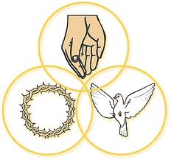

**The Father, the Son**

**and the Holy Spirit, three persons but one God.**

**All hail, adored Trinity:**

**All praise, eternal Unity.**

**ICDA Canadian Section**

**Chapter # 108**

**Website:**

[**www.DeafCatholicEdmonton.org**](http://www.DeafCatholicEdmonton.org)

**Charitable Donation Number**

**11918-6757-RR0001**

**Today’s Readings**

**First Reading:** Proverbs 8:22-31

**Psalm #** 8

**Second Reading:** Romans 5:1-5

**Gospel**: John 16:12-15

**Next Sunday – May 29th – CORPUS CHRISTI (Body of Christ)**

**First Reading:** Genesis 14:18-20

**Psalm #** 110

**Second Reading:** 1 Corinthians 11: 23-26

**Gospel:** Luke 9:11-17

**TODAY is the feast of the Holy Trinity, which is a mystery that we can’t fully understand – three persons in One God.**

**Notice: Next Sunday, May 29th** will be the feast of Corpus Christi.The **11:00 A.M. for the Deaf** here at Providence Centre will be cancelled that day and we will join the hearing people’s **Mass at 11:30 A.M. at Corpus Christi Parish, 2707 – 34 Street** on that one Sunday.

**May 29,30 and 31st – Deaf Retreat at Pigeon Lake.** Please bring something to share if you plan to go.We will leave after the Mass at Corpus Christi Church and return to Edmonton on Tuesday, May 31st.

Bring your rosaries with you.

**MAY BIRTHDAYS**

May 1st - Linda Guy May 2nd - Hilda Dziwenka

May 3rd – Neelam Parmar May 4th – Yvonne Tardif

May 5th - Nikko Paez May 10th – Emil Guy

May 12th – Bill Rodgers May 13th – Barbara Bjelke

May 17th – Anna Maria DeRose May 24th – Nellie Shores

**MINUTE MEDITATION**

God**,** who is Love itself, wanted to share goodness with others. God was not forced to share this goodness; God wanted to! God wanted to be our Father, to give us divine life, goodness, and happiness. from *Live* *Like Francis*

* *From Live Like Francis*

**Office and Mailing Address**

3005 - 119th Street • Edmonton, Alberta T6J 5R5 • (780) 436-7250