**MAY 8, 2016**

**ASCENSION OF THE LORD “C”**

**Happy Mother’s Day to all Mothers**

**Chaplain:**

Father Matthew Hysell, M.A., M.Th.

DeafCatholicEdmonton@CAEDM.ca

780-700-0234 text message only

In case of emergency, text to Father Matthew for assistance.

**Pastoral Worker**

Sister Elizabeth Kass, S.P.

780) 701-1817 *TTY*

780) 436-7255 *fax*

780) 446-7317 *text-message*

ekass@sistersofprovidence.ca *email*

**Chairperson**

Mr. John Sh

8640 *TTY*

John.Shores@ualberta.ca *email*

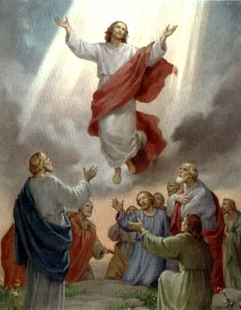

**Jesus ascends into heaven**

**as the apostles and others**

**watch.**

**ICDA Canadian Section**

**Chapter # 108**

**Website:**

[**www.DeafCatholicEdmonton.org**](http://www.DeafCatholicEdmonton.org)

**Charitable Donation Number**

**11918-6757-RR0001**

**Today’s Readings**

**First Reading:** Acts 1:11

**Psalm #** 47

**Second Reading:** Ephesians 1:17-23

**Gospel**: Luke 24: 46-53

**Next Sunday – May 15th – PENTECOST SUNDAY**

**First Reading:** Acts 2:1-11

**Psalm #** 104

**Second Reading:** 1 Corinthians 12:3-7, 12-13

**Gospel:** John 20:19-23

**Notice: Sunday, May 29th** will be the feast of Corpus Christi.The **11:00 A.M. for the Deaf** here at Providence Centre will be cancelled that day and we will join the hearing people’s **Mass at 11:30 A.M. at Corpus Christi Parish, 2707 – 34 Street** on that one Sunday.

**May 29,30 and 31st – Deaf Retreat at Pigeon Lake.** Please give us your name today if you plan to go.We will leave after the Mass at Corpus Christi Church and return to Edmonton on Tuesday, May 31st.

**MAY BIRTHDAYS**

May 1st - Linda Guy May 2nd - Hilda Dziwenka

May 3rd – Neelam Parmar May 4th – Yvonne Tardif

May 5th - Nikko Paez May 10th – Emil Guy

May 12th – Bill Rodgers May 13th – Barbara Bjelke

May 17th – Anna Maria DeRose May 24th – Nellie Shores

**MINUTE MEDITATION**

Acquire the habit of speaking to God as if you were alone with him, familiarly and with confidence and love, as to the dearest and most loving of friends. St. Alphonse de Ligouri

**MAY IS MARY’S MONTH**

The month of May is dedicated to Mary, our heavenly mother.

Father Matthew wants to have a May crowning of Mary’s statue by the grotto outside near the PRC.

* *From Live Like Francis*

**Office and Mailing Address**

3005 - 119th Street • Edmonton, Alberta T6J 5R5 • (780) 436-7250